Name Class Date

Hypothesis
The rate of photosynthesis depends on the amount of light.
Prediction
- Read the method and write a prediction by crossing out the wrong phrase in the brackets.
I think the gas will collect fastest when the light is (further away from/closest to) the beaker.
Method
Apparatus  - pondweed ● lamp ● narrow bung  - pond water ● large beaker ● ruler  - glass funnel ● marker pen ● stopclock |  |  Wash your hands after handling pondweed and pond water.
- Decide on your control variables and set them to a certain point.  - Alter the light intensity by clicking on the bulb. Note the value and record it in your table.  - Start the stopclock and count how many bubbles are give off in 30 secs.  - Change the light intensity and start again.  - Repeat for 5 different light intensities. | 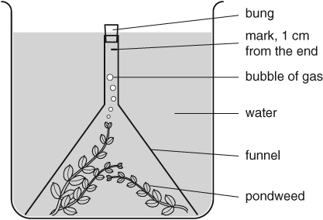
Recording your results
- Record your results in this table.
Light Intensity | Number of bubbles given off
7.96 | 8
31.85 | 28
127.39 | 105
510.20 | 106

Considering your results/conclusions
- Present your results as a scatter graph, on page 3.
- What gas was given off? oxygen
- Complete this sentence to describe the correlation between the light intensity
and the number of bubbles given off.
The greater the light intensity, the more oxygen given off meaning that there will be more bubbles

Evaluation
- There is a problem with this experiment. The lamp gives out heat that may heat up the water and give you a false result.
- How do you think having hotter water affects the results?
Because the heated water will boil giving you extra bubbles

- Why do you think this?
Because the water heats up

- Can you think of a way of stopping the lamp heating up the water? Describe your idea.
Place a transparent insulator over the lamp so the heat wont escape the lamp but the light will

I can…
- explain what happens when plants photosynthesise
- present data as a scatter graph
- explain how the rate of photosynthesis can be affected
- evaluate my method.

